1. **Evaluation of adaptive user interface**

In this master report our ongoing study into the evaluation of adaptive user interface will be discussed. First, in this chapter we will present a literature review of adaptation, and evaluation tools of adaptive user interface. In the survey of adaptation we will start with introducing our definitions and issues of adaptation and their intersection with the context, then we will present the two properties of adaptive user interface which are adaptivity and adaptability. In the review of evaluation tools, we will present the main definition of evaluation, and we will quote some criteria of user interface. Finally, we will continue with method and tools used to evaluate the adaptive user interface.

## Adaptation of user interface

Before we start to talk about evaluation of adaptive user interface we need to clarify the notion and the basic idea of adaptation, and to learn how adaptivity can be considered in user interface. So in this section, we will introduce our main definition and properties of user interface adaptation.

* + 1. **User interface adaptation and Context**

Nowadays, software artifacts become more and more interactive, online information and devices are becoming large in size, and user’s number and needs are increasing as well. This diversity and increasing, provoke the importance of adaptability and flexibility of user interface, and the necessity to take into account all elements that interact with it. So The main key of adaptation is its sensibility to the Context which is characterized by: User (U), Environment (E), and Platform (P), Dey and Abowd [Dey., 2001] [Dey & Abowd., 2000] define Context as:

*“Context is any information that can be used to characterize the situation of*  
*an entity. An entity is a person, place or object that is considered relevant to the*  
*interaction between a user and an application, including the user and the application*  
*themselves.”*

Therefore, systems adaptation and context modeling becomes the challenges of many researches, and many academic studies are conducted to take into account the context in application makes. Adaptation is characterized by its ability to make system intelligent and personalized that allows it to detect the variability of the Context of use. In our study we based on the following definition of adaptation to the context given by [Han et al., 1998]:

*“Adaptation is the process of selection, generation or modification of content (e.g., text, image, animation) to suit the user’s computing environment and context of use”*

Therefore context adaptation provides the opportunity to create personalized user interface able to detect and perceive characteristics of its specific environment, and adapt itself accordingly.

Recently there are many studies that considered the context in the user interface design (e.g. Calvary et al., 2003; Vanderdonckt, 2005; Taconet and Aoul, 2008; Ayed et al., 2007; Hachani et al., 2009, Bacha et al., 2011). These studies based on the information collected about the three dimension of Context (User, Platform, Environment) to determine the way in which should present the information and customize the interface for different devices [Bacha et al., 2011].

Bacha et al. reported that it is crucial to consider the context modeling in the design of user interface, and they analyzed all the concepts and proprieties of the 18 proposals of context, and they classified them in categories of concepts according to their meaning and they organize categories around the three main context dimensions proposed for UI design: User Modeling, Platform modeling, and environment modeling.

* + - 1. **User Modeling**

User modeling is defined as the representation of user characteristics which help to learn the profile of users by presenting them with a description of user’s attribute, age, gender, education level etc. [Bacha et al., 2011] divided user profile into five major categories that describe the user during its interaction with the platform: demographic information, contact information, user preferences, user state, and user abilities and proficiencies.

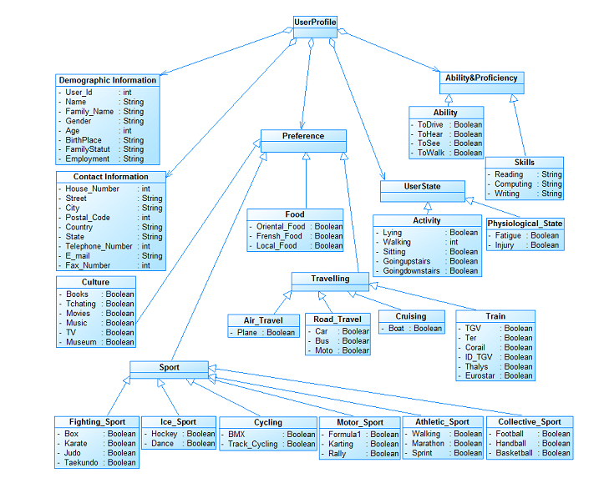

**Figure 2.1**: The user profile model [Bacha et al., 2011]

* + - 1. **Platform Modeling**

Platform modeling is generic way to characterize the platform and to describe the physical characteristics of the devices. According to [Bacha et al., 2011] platform divided into two parts:

* Hardware which composed on: memory, CPU, User interface characteristics, Network.
* And software that composed on: Operating system, application system, virtual machine, rendering engine.

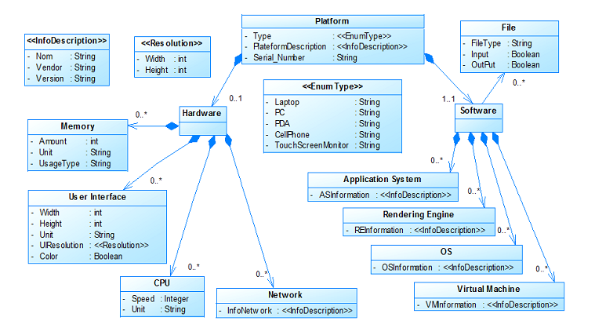

**Figure 2.2**: The platform model [Bacha et al., 2011]

* + - 1. **Environment Modeling**

According to [Bacha et al., 2011] this model describes all information about the environment where the interaction takes place between the user and the platform. And most of the information related to this model are dynamic and can impact the content to be presented. Environment divided into three main classes: location, time, and external event.

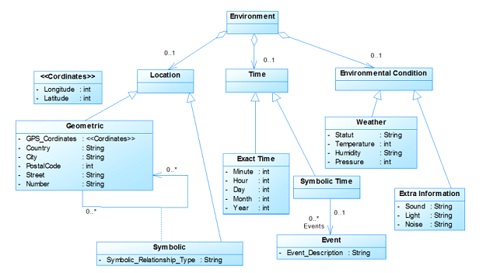

**Figure2.3**:Th environnement model [Bacha et al., 2011]

* + 1. **Adaptation and User Interface**

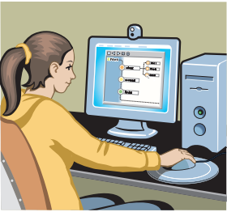

**Figure2.4** The interface is the part of the computer system with

which the user interacts in order to use the system and do his or her tasks.

Researchers and specialists of Human-computer interaction give more importance to user interface layers from the beginning part of design process in application makes, and insist to design and modeling user, environment, and platform. Indeed, users interact with a computer system via a User Interface (UI) for this reason it should be easy to use, easy to understand, and support users needs.

For user interface, the adaptation has been promoted to solve usability problems and to cater users needs and preferences, because it can be performed basically on the interface containers presentation such as layout, colors, sizes, and other design elements, and content like data, information, document [souii et al., 2015].

Moreover user interface adaptation deals with systems adaptation that considering by its sensibility of context of use. This kind of system subdivided into two types, *Adaptive* user interface system, in which case the adaptation was determined in the design phase and the user cannot express any choice. And *Adaptable* user interface system, in which case the adaptation is only done if user has explicitly asked for it [Velsen et al., 2008]. An important distinction exists between an adaptive and an adaptable interface that we will detail in the two following subsections.

**User Interface**

**Adaptive** User Interface

Tailors its output using ***implicit*** inference based on the interaction with user

**Adaptable** User Interface

Use ***explicitly*** provided input to customize output

**Figure 2.4 :** adaptive user interface vs. Adaptable user interface

## Adaptivity of user interface

Adaptive user interfaces (AUIs) are defined as “*systems that adapt their displays and available actions to the user’s current goals and abilities by monitoring user status, the system state and the current situation”* [Rothrock et al., 2002].

The adaptive user interface was implicitly adapted themselves. It allows system to adapt their structure, functionality or interface based on the user model generated from an implicit user input [beyond et al., 1987]. According to [Gullà et al., 2011], adaptivity aims to facilitate the interaction between user and interface by using an adaptation strategy that can detect the current situation of user, environment, and platform and generate the appropriate interface at the run time. And adaptive user interface seems to help to improve user interaction with systems by facilitating user task and performance, minimizing the need to request help, easing system use, helping users deal with complex systems, and avoiding cognitive overload problems. To acquire implicit adaptation developers investigate user’s profile modeling, advertisements, questionnaire, and survey in the design of user interface to make decision and adding an inference mechanism.

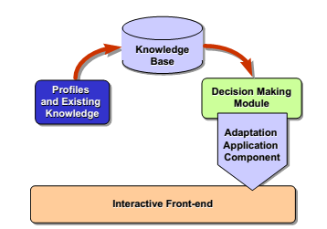

**Figure 2.5**: Abstract system architecture for supporting adaptability

[Stephanidis, Paramythis et al., 1998].

Today, many companies offer adaptivity on their web site such us Google which personalized advertisements, language, component adjusted to the user’s most recent search queries and according to their location. Another example is Amazon Web site with its product recommendation mechanism. And Pandora application radio which personalize the choice of radio station. Windows also have some experience with adaptive user interface the most known example is Windows start menu that present a set of applications based on their relative frequencies of use to providing an easier access.

## Adaptability of user interface

Adaptable user interfaces are defined as “*Adaptable systems can alter aspects of their structure, functionality or interface on the basis of a user model generated from explicit user input, in order to accommodate the differing needs of individuals or groups of users and the changing needs of users over time”*[ beyond et al., 1987].

In contrast of adaptive user interface, adaptable UI refer to the self-adaptation because it provides users the ability to modify and customize explicitly the interface according to their own needs and to follow their preference and tasks. Not all adaptation needs to be applied before interaction starts (at run time), for this reason adaptability used to provide the best mapping between user and interface during all the interaction process. Also it often used to refer to customizability by the end user [Paramythis., 2009]. Adaptability gives users the ability to select the appropriate interaction way that they need from an alternative presentation and interaction characteristics through the selection of a specific user profile from a predefined list [Gullà et al., 2011].

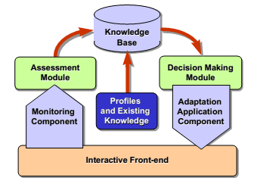

**Figure 2.6** Abstract system architecture for supporting adaptivity

[Stephanidis, Paramythis et al., 1998].

 iGoogleis an example of adaptable system, which give users the ability to modify the location and number of the components according to their needs. It gives users the ability to select the content that they need from list of gadget exist or create a new gadget that they need, and to choose the location and size of components. See the screenshot below for a different components based on Google’s user research.

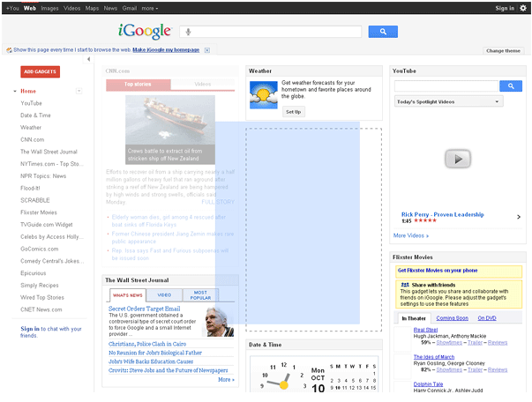 

1. (b)

**Figure 2.7**: (a) and (b), is two screenshot for different Google’s research

# Adaptive user interface evaluation

Evaluation is widely considered as an important and challenging research issue in the area of adaptive user interface. However, evaluate the user interface by considering the context of uses and the human-computer interaction is a quite difficult task because the evaluation will require analysis of real users in a real context.

In this section we will present the definition and principle of evaluation, methods and techniques used to evaluate adaptive and adaptable user interface, existing tools, and we going to present the criteria of user interface which enhance and enhance the adaptivity for user interface.

* + 1. **The evaluation: definitions and principles**

Literature on adaptive user interface is very diverse, and researchers come from diverse scientific disciplines, each group of them design and evaluate user interface adaptation based on their point of view. As a result, in the research field of adaptive user interface, there is any standard definition or evaluation method that has been shown to be applicable at a general level.

[Le Bodic., 2005] define evaluation as method which consists in the checking of adequacy between functional realization and the scenario of usage. Also, according to [Karat., 1997], evaluation is “ the result of a process with a purpose in a context focused on an object”.

So, Evaluation of adaptive user interface has been used to compare user interface with their capacity to adapt to their real context of use. And it allows determining the accuracy and the adequacy between the interface and user’s preference, user’s need, platform used, and environment, in other word it allows to determine how accurately adaptation satisfies the needs of users. According to [Bellotti et al.2002] and [Arhippainen et al., 2003] the evaluation of adaptive system and their influence on users is quite difficult because the evaluation will require analysis of real users in a real context, and test users should have a fully operational, reliable and robust tool.

* + 1. **Evaluation Criterion of user interface**

Before we turn to our study, we need to present the criterion that can be used to evaluate adaptation of user interface and what to measure when evaluating the adaptation. According to [Bacha et al., 2011] user interface of such systems should not only be customized in terms of layout, screen resolution, and other design aspects, but should also provide the user with pertinent information that takes into account the ***context*** when using the system. Also some approaches emerged to consider the context in the user interface design. So the quality of user interface depends on its capacity to adapt to their users profile, platform, and environment. And to evaluate adaptation of user interface we need to verify the way in which the interface is able to change due to each specific context of use.

Bastien and Scapin define some ergonomic criterion which support the evaluation of user interface, help to organize it, and increase its completeness [Bastien and Scapin., 1993]. The most important criterion was: guidance, workload, explicit control, adaptability, error management, consistency, compatibility, significance of code.

* **Guidance:** “User Guidance refers to the means available to advise, orient, inform, instruct, and guide the users throughout their interactions with a computer (messages, alarms, labels, etc.), including from a lexical point of view”.

This criterion provides users to know the sequence of action depending on the context. And good guidance facilitates learning and using the interface, and lead to better performances and fewer errors.

* **Workload:** “The criterion workload concerns all interface elements that play a role in the reduction of the users’ perceptual or cognitive load, and in the increase of the dialogue efficiency”.

This criterion represents the density of interface, when high density of interface can increase the probability to make much error and limit the learnability of interface.

* **Explicit Control:** “The criterion Explicit Control concerns both the system processing of explicit user actions, and the control users have on the processing of their actions by the system.”

Bastien and Scapin reported that user and interface should have an explicit control, and we have to control the relationship between application processing and the action of users. And the system will be better accepted by users if they have control over the dialogue.

* **Adaptability:** “The adaptability of interface refers to its capacity to behave contextually and according to the users’ needs and preferences.”

Adaptability depends on the capacity of interface to be flexible and to support user experience. Interface should present different options, layout, color, luminosity, etc, to follow the context of users and to achieve their goal.

* **Error Management:** “The criterion Error Management refers to the means available to prevent or reduce errors and to recover from them when they occur. Errors are defined in this context as invalid data entry, invalid format for data entry, incorrect command syntax, etc.”

Bad interactions with the interface caused by users’ errors have negative consequences on the users’ activities. When we limiting the number of users’ errors, the bad interactions with the interface is also limited, and the performance is thus better.

* **Consistency:** “The criterion Consistency refers to the way interface design choices (codes, naming, formats, procedures, etc.) are maintained in similar contexts, and are different when applied to different contexts.”

This criterion provides that the interface become more predictable, learning and generalization are facilitated, and the number of errors made is reduced. A lack of consistency can increase the search time considerably and caused users’ rejection.

* **Significance of codes:** “The criterion Significance of Codes qualifies the relationship between a term and/or a sign and its reference. Codes and names are significant to the users when there is a strong semantic relationship between such codes and the items or actions they refer to.”
* **Compatibility:** “The criterion Compatibility refers to the match between users’ characteristics (memory, perceptions, customs, skills, age, expectations, etc.) and task characteristics on the one hand, and the organization of the output, input, and dialogue for a given application, on the other hand.”

The criterion Compatibility provides interface to be appropriate and compatible with user profile, platform, and environment. So it guarantees the coherence of interface. Also it increases the efficiency because it makes procedures and tasks more organized.

* + 1. **Existing tools /methods for adaptive user interface evaluation**

In literature there a few studies that present method to evaluate adaptive user interface. In general, there are three known approach for evaluation that can be adopted to evaluate adaptive user interface which are:

* Empirical evaluation: which characterized by using observation techniques in experiments, such as interviews, questionnaire, analyze of trace of use, etc. This type of evaluation used a lot to evaluate user interface because in this case we can used the final system or interface to observe and analyze the interaction between users and interface.
* Expert evaluation: “This type of evaluation based on the judgment of an expert in ergonomics or a specialist in human-machine interaction. It compares the performances and characteristics which are presented in the form of specifications, model or of prototype, to the standards or recommendations in order to detect a design errors” [Soui et al., 2012 ]
* Analytical evaluation: it is a theoretical approach that evaluates the design or code of interface. According to [Soui et al., 2012 ] we can classify analytical approaches into the following three categories: (1) the predictive models that are based on breaking down the tasks of potential users into users’ actions and users’ cognitive processes, (2) the automatic evaluation tools which analyze and verify the UI code and (3) the simulation methods [Feng et al. 2009].

In the following of this subsection we will quote some method and tools used to evaluate adaptive user interface:

[Stephanidis et al., 1999] They reported an expert assessment approach for adaptation characteristic of AVANTI Web browser user interface. They provided two-fold assessment process. The first one, consist to assess the appropriateness of design interaction style based on user and usage characteristic. The second one, consist to evaluate the overall usability of the AVANTI information system. They evaluate: learnability, efficiency of use, memorability, errors, satisfaction, user attitude, and adaptability and adaptivity of the interface, by using qualitative and quantitative methods.

[Paramythis et al., 2001] they proposed a new modular approach to evaluate AUIs. They identify “modules” of AUIs which can be evaluating either separately or in combination (the evaluation objects). They present the evaluation rationale underlying the decomposition of AUIs into modules and the subsequent assessment of these modules, based on specific criteria (the evaluation purpose). Finally they present the methods and techniques that can be employed for the evaluation of the different “modules”, in the different stages of the AUI development lifecycle (the evaluation process).

[McGrenere et al., 2002] they have utilized comparison method to evaluate adaptive and adaptable interface. They compare between an interface personalized by the user containing desired features only, and the default interface with all the standard features. The study tested the effects of different interface designs on users’ satisfaction and their perceived ability to navigate, control, and learns the software. And they have shown that the personalized interface is the preferred one. They concluded that it is difficult to interpret this result, because the two user interface designs were present different functionality. And this result can be caused due to the difference in the complexity of the two interfaces, or to the fact that one of them has an adaptive behavior.

In addition, in continuous research, [Findlater and McGrenere., 2004] shown study that compare also between static, customizable, and adaptive versions of split menus, from this study, they concluded that user-controlled customization is a feasible approach for personalizing UIs than system-controlled interfaces automatic adaptation. In a more recent study, [Findlater and Mcgrenere., 2008] have provided empirical evaluation that compare 36 different subjects of adaptive interfaces for small and desktop-sized screens, in other words they compare adequacy between interface and platform. They have shown that AUIs are more beneficial when screen real estate is constrained, and that the adaptive accuracy conditions were better in the small screen displays compared to the desktop sized displays.

[Tsandilas and Schraefel ., 2005] reported an empirical assessment to determine the effectiveness of user interface, they examined two adaptation techniques applied on list of textual selection. Also [Gajos et al. (2006)] they reported two experiment in which they compare three adaptive users interface.

[Alemerien and Magel., 2014] they present GUIEvaluator which is a metric-based tool built to evaluate automatically the complexity of user interface based on five quantitative metric (Alignment, grouping, size, density, and balance), which are considered significant influences on interface usability.

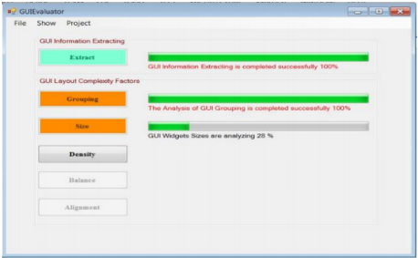

**Figure 2.8**: The extraction and analysis window of the GUIEvaluator

[Alemerien and Magel., 2014]

Furthermore, Alemerien and Magel present another tool GUIExaminer [Alemerien and Magel., 2015] which support SLC metric (Screen Layout Cohesion). This metric used to predict the usability of user interface and it is considered as a hybrid metric because it is measured based on the structural, aesthetic, and semantic aspects of GUI layouts.

These last two tools represent an analytical evaluation that evaluate automatically “static” user interface, based on metrics calculation. In contrast, the evaluation of “dynamic” user interfaces lack of appropriate tools that evaluate automatically the adaptivity and adaptability of interface. Another issue is considered in the studies that present a comparison methods between adaptive and non-adaptive user interface, the problem is obvious: the non-adaptive system may not have been designed ’optimally’ for the task. Today there are many established approaches and frameworks for the design and implementation of AUIs, but their evaluation is yet to be addressed in a comprehensive way.

* 1. **Conclusion**

In this chapter we have introduced a review of related literature from several references about adaptive and adaptable user interface and its evaluation.

First we have reviewed the adaptation of user interface. We have started by presenting the appearance of context adaptation in design of user interface. Then we have presented their two main properties. Adaptivity which simplify and speed up the activity of user by an implicit adaptation. And adaptability which delegates the management of some interaction activities to users, and system plays a limited role of support by providing an explicit adaptation.

Then we have presented criterion of user interface that help to evaluate the interface and to determine their level of adaptivity. And we have presented some studies which reported evaluation methods for adaptive and adaptable user interface. Evaluating adaptive user interface means evaluate the ability of interface to adapt for diverse number of end-users and context of use, and implies making alternative evaluation decision, at various kind of the interaction.

In the next chapter we will introduce our contribution and method proposed to evaluate automatically the adaptive user interface and take into account the context of use in the assessment of interface.

* 1. **Conclusion**

In this chapter we have introduced a review of related literature from several references about adaptive and adaptable user interface and its evaluation.

First we have reviewed the adaptation of user interface. We have started by presenting the appearance of context adaptation in design of user interface. Then we have presented their two main properties. Adaptivity which simplify and speed up the activity of user by an implicit adaptation. And adaptability which delegates the management of some interaction activities to users, and system plays a limited role of support by providing an explicit adaptation.

Then we have presented criterion of user interface that help to evaluate the interface and to determine their level of adaptivity. And we have presented some studies which reported evaluation methods for adaptive and adaptable user interface. Evaluating adaptive user interface means evaluate the ability of interface to adapt for diverse number of end-users and context of use, and implies making alternative evaluation decision, at various kind of the interaction.

In the next chapter we will introduce our contribution and method proposed to evaluate automatically the adaptive user interface and take into account the context of use in the assessment of interface.